**Week 1: Install and set up java environment**

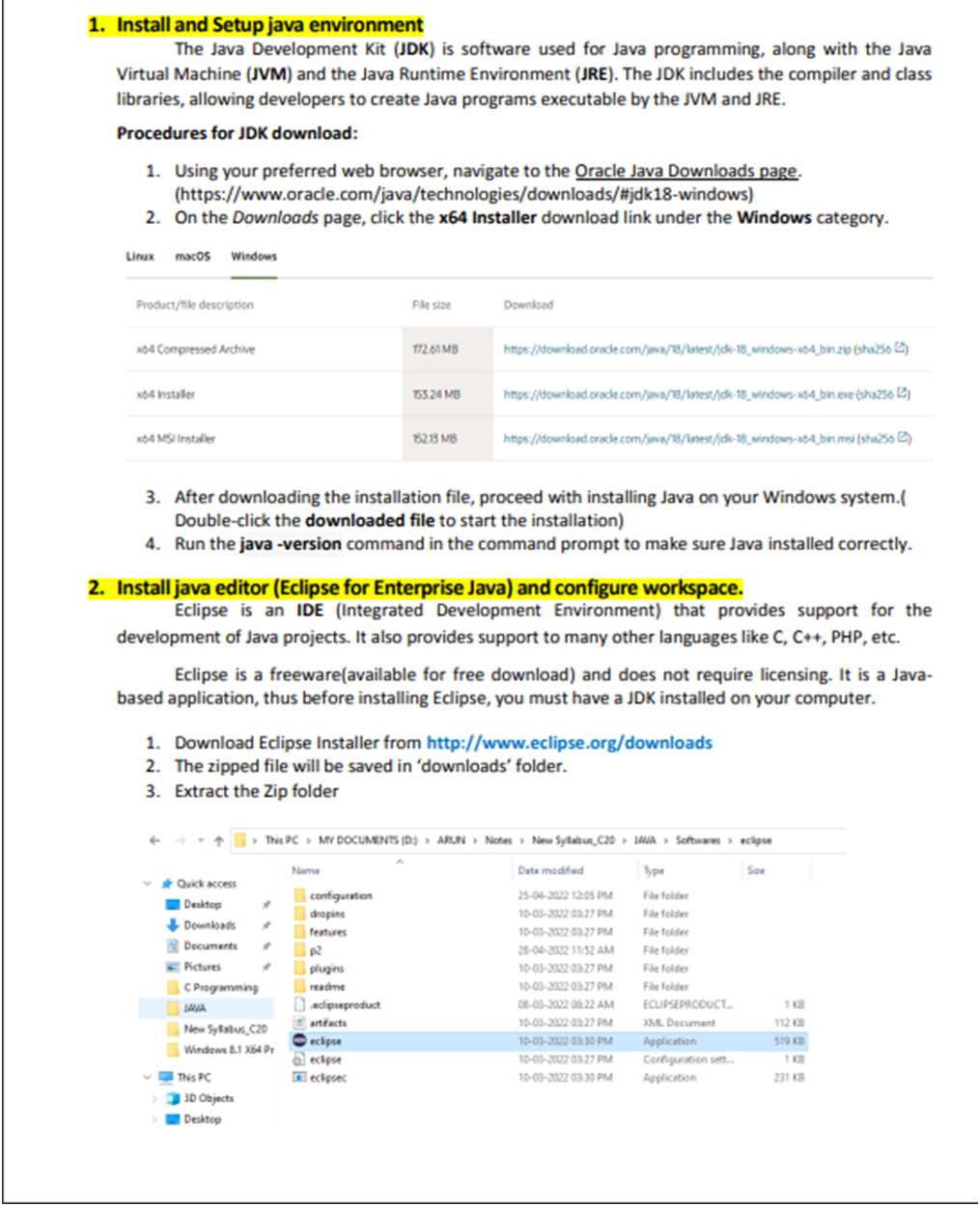

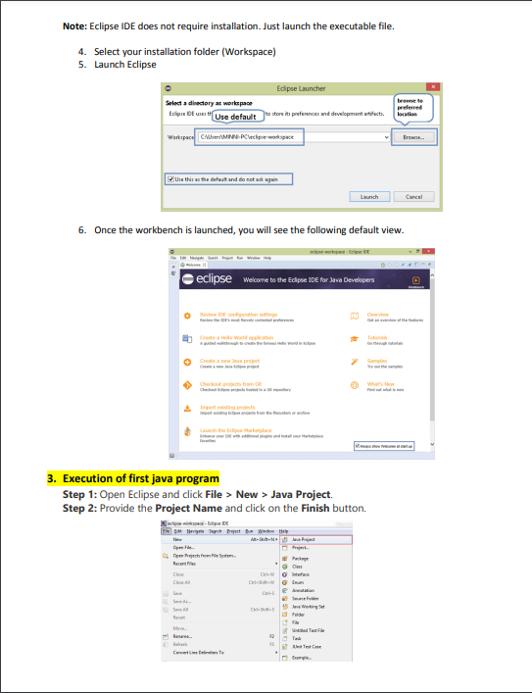

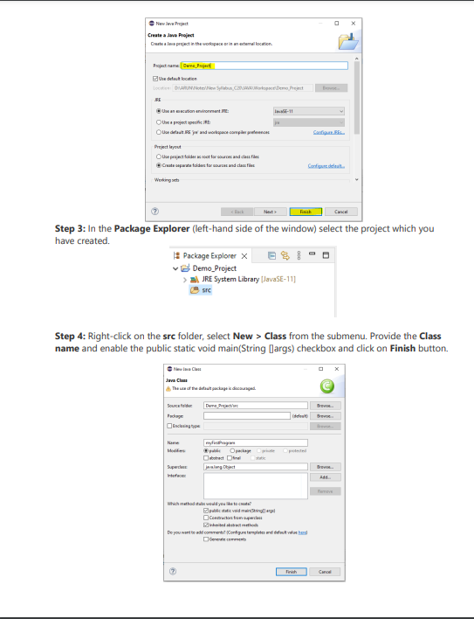

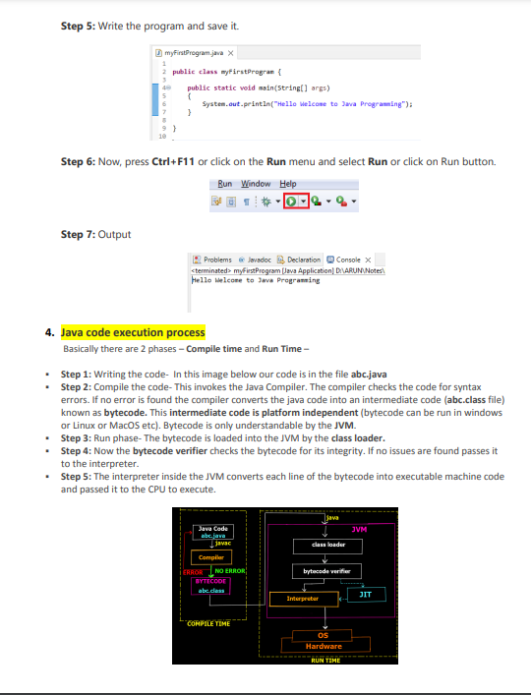

**Week 2**

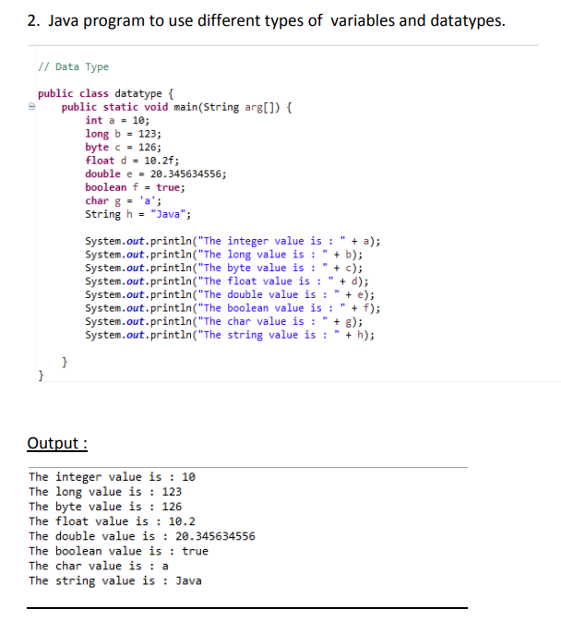

**Week-3**

3a.Java program that uses different types of constructors.

**public** **class** Student {

**int** id;

String name;

**int** age;

Student(){ //default constructor

id = 03;

name = "Ananya";

age = 17;

}

Student(**int** i, String n, **int** a){ //parameterized constructor

id = i;

name = n;

age = a;

}

**void** display() {

System.***out***.println("The id is : " + id);

System.***out***.println("The name is : " + name);

System.***out***.println("The age is : " + age);

System.***out***.println();

}

**public** **static** **void** main(String args[]) {

Student ob1 = **new** Student();

ob1.display();

Student ob2 = **new** Student(1, "abhi", 18);

ob2.display();

}

}

Output:

The id is : 3

The name is : Ananya

The age is : 17

The id is : 1

The name is : abhi

The age is : 18

3b. Java program to evaluate expression.

**public** **class** expr {

**public** **static** **void** main(String arg[]) {

**int** a = 6, b = 9, c = 2, d = 3;

**int** ans = c + (a+b)*c/++d - a;

System.***out***.println("The result is : "+ ans);

}

}

Output:

The result is : 3

3c. Java program to perform autoboxing and unboxing.

**public** **class** box {

**public** **static** **void** main(String args []) {

**int** a = 50;

Integer a2 = **new** ~~Integer~~(a); // Boxing

System.***out***.println("The integer object value is : " + a2);

Integer a3 = 5;

**int** a4 = a3; // unboxing

System.***out***.println("The integer datatype value is : " + a4);

}

}

Output:

The integer object value is : 50

The integer datatype value is : 5

**Week-4**

**1. Install memory monitoring tool and observe how JVM allocates memory**

**2. Memory allocation explanation through the programs.**

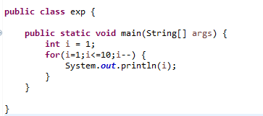 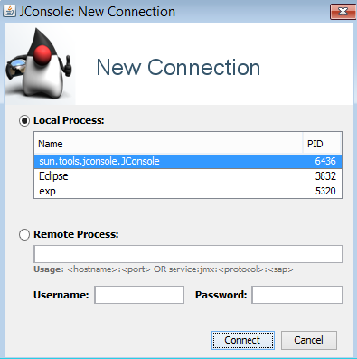

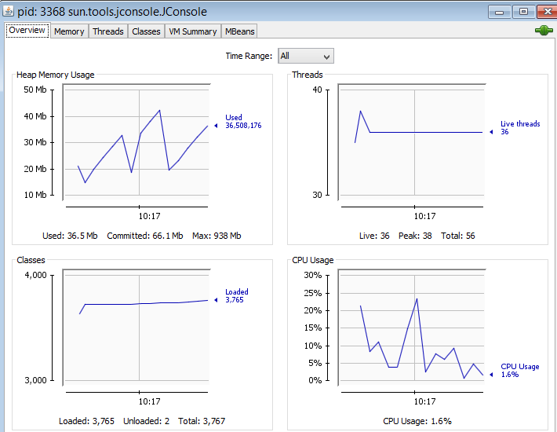

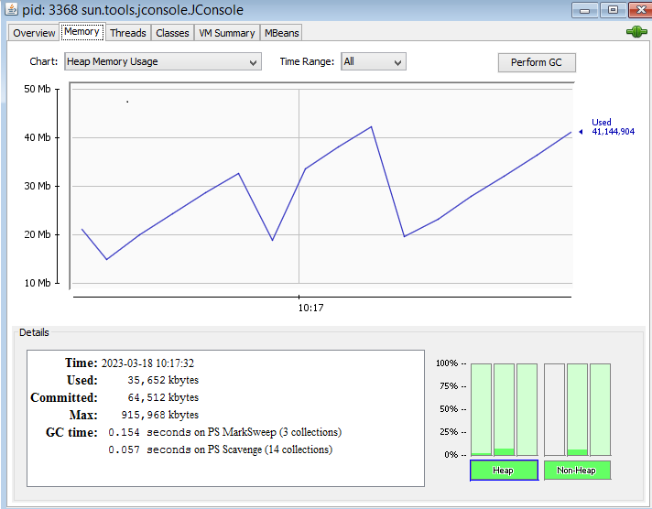

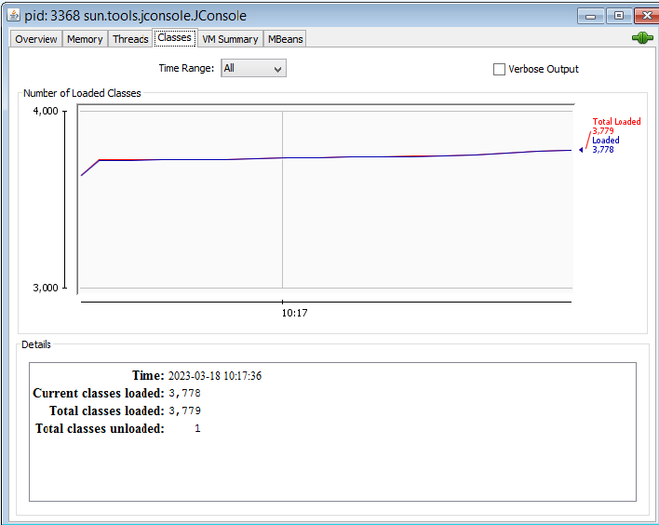

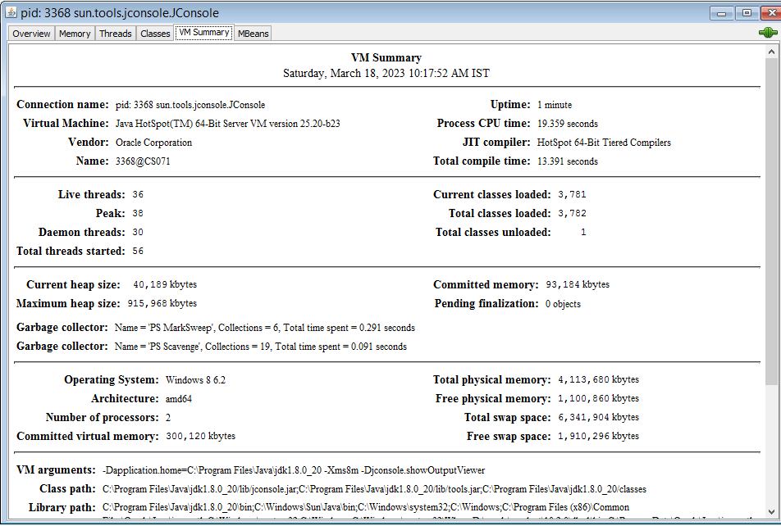

**Steps to use memory monitoring tool:**

Step1: Open eclipse and write an infinite loop given below.

**public** **class** exp {

**public** **static** **void** main(String[] args) {

**int** i = 1;

**for**(i=1;i<=10;i--) {

System.***out***.println(i);

}

}

}

Step2:Run the program.

Step3:Open JDK folder --> Bin and search for “jconsole.exe” and open the application.

Step4:Select your program name in local process and connect.

Step5: Select insecure connection and you will be able to view the memory allocation.

**Week-5**

**5. Java program that uses different control statement.**

5a. Java program that uses simple if statement.

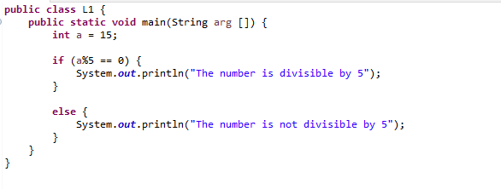 Output -

so.PNG

5b. Java program that uses if else ladder statement.

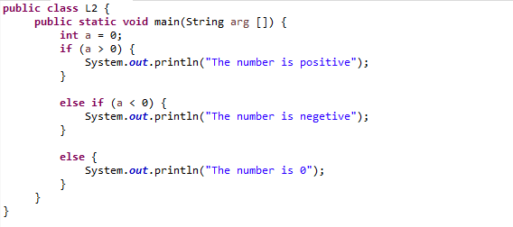

Output -

eo.PNG

5c. Java program that uses Nested if statements.

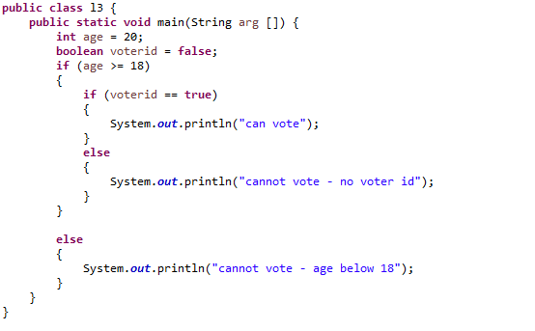

Output -

no.PNG

5d. Java program that uses for loop.

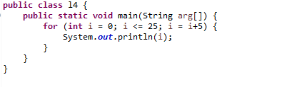

Output -

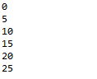

e. Java program that uses while loop.

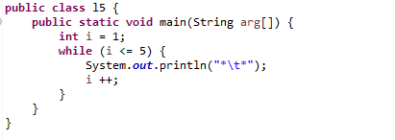

Output -

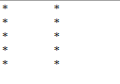

5f. Java program that uses do-while loop.

**public** **class** l6 {

**public** **static** **void** main(String arg[]) {

**int** i = 5;

**do** {

System.***out***.println(i);

i --;

} **while** (i>= 0);

}

}

Output -

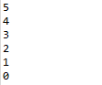

5g. java program that uses for-each loop.

**public** **class** prg1 {

**public** **static** **void** main(String arg []) {

**int** arr [] = {5, 6, 7, 8, 9, 1};

**int** total = 0;

**int** min = arr[0];

System.***out***.println("The array elements are : ");

**for** (**int** a: arr) {

System.***out***.println(a);

}

**for** (**int** a: arr) {

total = total + a;

}

System.***out***.println("The total is : " + total);

**for** (**int** a: arr) {

**if** (min>a) {

min = a;

}

}

System.***out***.println("The smallest is : " +min);

}

}

**Output:**

5

6

7

8

9

1

The total is : 36

The smallest is : 1

**Week-6**

6a. Java program to use encapsulation concept.

**public** **class** Person {

**private** String name;

**private** **int** age;

**public** **void** set_name(String n) {

name = n;

}

**public** **void** set_age(**int** a) {

age = a;

}

**public** **int** get_age() {

**return** age;

}

**public** String get_name() {

**return** name;

}

**public** **static** **void** main(String[] args) {

Person ob1 = **new** Person();

ob1.set_name("Guru");

ob1.set_age(18);

String n = ob1.get_name();

**int** a = ob1.get_age();

System.***out***.println("Name of the person is : " + n);

System.***out***.println("Age of the person is : " + a);

}

}

Output :

Name of the person is : Guru

Age of the person is : 18

6b. Java program to check compliance with SRP.

**public** **class** calculator {

**int** n1, n2, ans;

**void** set(**int** x, **int** y) {

n1 = x;

n2 = y;

}

**void** add() {

ans = n1 + n2;

System.***out***.println("The sum is : " + ans);

}

**void** sub() {

ans = n1 - n2;

System.***out***.println("The difference is : " + ans);

}

**void** mul() {

ans = n1 * n2;

System.***out***.println("The product is : " + ans);

}

**void** div() {

ans = n1 / n2;

System.***out***.println("The quotient is : " + ans);

}

**public** **static** **void** main(String arg[]) {

calculator ob1 = **new** calculator();

ob1.set(55, 24);

ob1.add();

ob1.sub();

ob1.mul();

ob1.div();

}

}

Output:

The sum is : 79

The difference is : 31

The product is : 1320

The quotient is : 2

**Week-7**

7a. Java program that uses array concepts.

**public** **class** prg1 {

**public** **static** **void** main(String arg []) {

**int** arr [] = {5, 6, 7, 8, 9, 1};

**int** total = 0;

**int** min = arr[0];

System.***out***.println("The array elements are : ");

**for** (**int** a: arr) {

System.***out***.println(a);

}

**for** (**int** a: arr) {

total = total + a;

}

System.***out***.println("The total is : " + total);

**for** (**int** a: arr) {

**if** (min>a) {

min = a;

}

}

System.***out***.println("The smallest is : " +min);

}

}

**Output:**

5

6

7

8

9

1

The total is : 36

The smallest is : 1

7b. Java program to perform string manipulation.

**public** **class** prg2 {

**public** **static** **void** main(String arg []) {

String str = **new** String("Welcome to jss polytechnic");

System.***out***.println("The length of string is : " + str.length());

System.***out***.println("The character at index 5 is : " + str.charAt(5));

System.***out***.println("The index of character 'j' is : " + str.indexOf('j'));

System.***out***.println("converted to lower case is : " + str.toLowerCase());

System.***out***.println("converted to upper case is : " + str.toUpperCase());

System.***out***.println("to check if the string is equal to 'jss' : " + str.equals("jss"));

System.***out***.println("concat string with hello : " + str.concat(" hello"));

System.***out***.println("The sub string from index 7 is : " + str.substring(7));

System.***out***.println("The sub string from index 3 to 10 : " + str.substring(3, 10));

}

}

**Output:**

The length of string is : 26

The character at index 5 is : m

The index of character 'j' is : 11

converted to lower case is : welcome to jss polytechnic

converted to upper case is : WELCOME TO JSS POLYTECHNIC

to check if the string is equal to 'jss' : false

concat string with hello: Welcome to jss polytechnic hello

The sub string from index 7 is : to jss polytechnic

The sub string from index 3 to 10 : come to

**Week-8**

**8a. Java program that uses inheritance concept**

**class** person{

String name;

**int** age;

**char** gender;

**void** setp(String n, **int** a, **char** g) {

name = n;

age = a;

gender = g;

}

**void** displayp() {

System.***out***.println("Name is : " + name);

System.***out***.println("Age is : " + age);

System.***out***.println("Gender is : " + gender);

}

}

**public** **class** student **extends** person {

**int** rollno;

String dept;

**void** sets(**int** r, String d) {

rollno = r;

dept = d;

}

**void** displays() {

System.***out***.println("Roll number is : " + rollno);

System.***out***.println("Department is : " + dept);

}

**public** **static** **void** main(String [] arg) {

student ob = **new** student();

ob.setp("Ahmed", 18, 'M');

ob.sets(003, "Computer Science");

ob.displayp();

ob.displays();

}

}

Output:

Name is : Ahmed

Age is : 18

Gender is : M

Roll number is : 3

Department is : Computer Science

**8b. Java program to check compliance with OCP.**

**interface** Shape{

**public** **abstract** **void** area();

}

**class** rectangle **implements** Shape{

**public** **void** area() {

**int** l = 3;

**int** b = 4;

**int** ans = l*b;

System.***out***.println("The area of rectangle is : " + ans);

}

}

**public** **class** circle **implements** Shape{

**public** **void** area() {

**float** r = 10.4f;

**float** ans = 3.14f*r*r;

System.***out***.println("The area of circle is : " + ans);

}

**public** **static** **void** main(String[] args) {

rectangle ob1 = **new** rectangle();

ob1.area();

circle ob2 = **new** circle();

ob2.area();

}

}

output:

The area of rectangle is : 12

The area of circle is : 339.62238

**Week-9**

**9. Java program that uses**

1. **Static binding- method overloading**

**public** **class** prg1 {

**void** add(**int** a, **int** b){

**int** ans = a+b;

System.***out***.println("The sum of integers is : " + ans);

}

**void** add(**float** a, **float** b){

**float** ans = a+b;

System.***out***.println("The sum of float is : " + ans);

}

**void** add(String a, String b){

String ans = a+b;

System.***out***.println("The sum of strings is : " + ans);

}

**public** **static** **void** main(String[] args) {

prg1 ob1 = **new** prg1();

ob1.add(10, 20);

ob1.add(10.30f, 20.20f);

ob1.add("jss", " polytechnic");

}

}

output:

The sum of integers is : 30

The sum of float is : 30.5

The sum of strings is : jss polytechnic

**9B. dynamic binding- method overriding**

**class** p1{

**void** display(**int** a) {

System.out.println("The value of a in class p1 : " + a);

}

}

**public** **class** p2 **extends** p1 {

**void** display(**int** a) {

System.out.println("The value of a in class p2 : " + a);

}

**public** **static** **void** main(String arg []) {

p1 ob1 = **new** p1();

ob1.display(18);

p1 ob2 = **new** p2();

ob2.display(20);

}

}

output:

The value of a in class p1 : 18

The value of a in class p2 : 20

**Week-10**

**10a. Java program that uses abstract class to achieve abstraction.**

**abstract class** shape{

**abstract void** area();

}

**class** circle extends shape {

**void** area() {

**float**r = 10.4f;

**float**ans = 3.14f*r*r;

System.***out***.println("The area of the circle is : " + ans);

}

}

**public class** rectangle extends shape {

**void** area() {

**int** l = 10;

**int** b = 30;

**int** ans = l*b;

System.***out***.println("The area of the rectangle is :" + ans);

}

**public static void** main(String[] args) {

circle ob1 = **new** circle();

ob1.area();

rectangle ob2 = **new** rectangle();

ob2.area();

}

}

Output:

The area of the circle is : 339.62238

The area of the rectangle is : 300

**10b. Java program that uses interface to achieve abstraction.**

**interface** shape{

**public abstract void** area();

**static final float *pi*** = 3.14f;

}

**class** rectangle **implements** shape{

**public void** area() {

**int** l = 10;

**int** b = 20;

**int** ans = l*b;

System.***out***.println("The area of the rectangle is : " + ans);

}

}

**public class** circle **implements** shape {

**public void** area() {

**float**r = 10.2f;

**float** ans = ***pi***\*r*r;

System.***out***.println("The area of the circle is : " + ans);

}

**public static void** main(String [] arg){

rectangle ob1 = **new**rectangle();

ob1.area();

circle ob2 = **new** circle();

ob2.area();

}

}

Output:

The area of the rectangle is : 200

The area of the circle is : 326.68558

**Week-11**

**11a.Program to handle unchecked exception.**

public class A {

public static void main(String[] args)

{

int a=10;

int b=0;

try

{

int ans =a/b;

System.out.println(ans);

}

catch(ArithmeticException ob)

{

System.out.println("Divide by zero error");

}

}

}

**Output:**

Divide by zero error

**11b.Program to handle checked exception.**

import java.io.*;

public class prog11b {

public static void main(String[] args) throws Exception

{

FileWriter fw = new FileWriter("D:\\demo.txt");

fw.write("Hello I am writing into file - demo.txt");

fw.close();

System.out.println("successfully wrote to the file.");

}

}

**Output:**

successfully wrote to the file.

**11c.Program to read from a file and write to another file.**

import java.io.*;

public class prog11c {

public static void main(String[] args) throws Exception

{

FileReader fr = new FileReader("D:\\demo1.txt");

FileWriter fw =new FileWriter("D:\\demo2.txt");

int i;

while((i=fr.read( ))!= -1)

fw.write(i);

fr.close();

fw.close();

System.out.println("successfully wrote to the file demo2.txt");

}

}

**Output:**

successfully wrote to the file demo2.txt

**11d.Program to handle exception.**

public class array1 {

public static void main(String[] args)

{

int arr[] = {33,3,4,5,66,16};

try

{

System.out.println("The array elements are");

for(int i=0;i<6;i++)

System.out.println(arr[i]);

}

catch(ArrayIndexOutOfBoundsException ob)

{

System.out.println("Array index error");

}

}

**Output:**

The array elements are

33

3

4

5

66

16

Array index error

**Week - 12**

1. **Java program to implement ISP (Interface Segregation principle).**

interface toy {

public void set(double p,String s);

public void display( );

}

interface moveable {

public void move( );

}

interface flyable{

public void fly( );

}

class teddy implements toy {

double price;

String colour;

public void set(double p,String c) {

price=p;

colour=c;

}

public void display( ){

System.***out***.println("teddy price is "+price);

System.***out***.println("teddy colour is "+colour);

}

}

class cartoys implements toy,moveable {

double price;

String colour;

public void set(double p,String c) {

price=p;

colour=c;

}

public void display( ) {

System.***out***.println("car toy price is"+price);

System.***out***.println("car colour is"+colour);

}

public void move( ){

System.***out***.println("the radio control car moves at 40kmph");

}

}

public class planetoys implements toy, moveable, flyable{

double price;

String colour;

public void set (double p,String c) {

price=p;

colour=c;

}

public void display( ) {

System.***out***.println("plane toy price is "+price);

System.***out***.println("plane toy colour is "+colour);

}

public void move( ) {

System.***out***.println("the radio control plane moves at 40kmph");

}

public void fly( ) {

System.***out***.println("plane toy flies");

}

public static void main (String[] args) {

teddy ob1=new teddy();

ob1.set(120.3, "red");

ob1.display( );

cartoys ob2=new cartoys();

ob2.set(200, "yellow");

ob2.display( );

ob2.move( );

planetoys ob3=new planetoys( );

ob3.set(3000, "white");

ob3.display( );

ob3.move( );

ob3.fly( );

}

}

**Output:**

teddy price is 120.3

teddy colour is red

car toy price is200.0

car colour is yellow

the radio control car moves at 40kmph

plane toy price is 3000.0

plane toy colour is white

the radio control plane moves at 40kmph

plane toy flies

**Week-13**

**Steps to execute program :**

1. Create the following table in mysql workbench.

|  |  |  |
| --- | --- | --- |
| **Name** | **regno** | **branch** |
| abhi | 12 | EC |
| Adithya | 17 | CS |
| ahmed | 11 | CS |
| Amog | 156 | CS |
| Guru | 14 | CE |
| Kushal | 13 | ME |

1. Type the program in Eclipse.

**Steps to download JDBC connector:**

1. In Google, search for mysql connector for java.
2. Select mysql.com website.
3. Choose platform independent in the drop down menu
4. Download .zip file.
5. Extract the downloaded file.

**Steps to load .jar file in eclipse:**

1. Project > properties > Java build path > libraries > module path > add external .jar file > select the extracted .jar file (mysql-connector-j-8.0.33).
2. Click apply and close.

**13.a Java program to display contents of table using mysql and jdbc.**

**import** java.sql.*;

**public** **class** database {

**public** **static** **void** main(String arg []) **throws** Exception {

Class.*forName*("com.mysql.cj.jdbc.Driver");

Connection con = DriverManager.*getConnection*("jdbc**:**mysql**://**localhost**:**3306**/**exam"**,** "root"**,** "Tiger@123")**;**

Statement stmt = con.createStatement();

ResultSet rs = stmt.executeQuery("select * from student");

System.***out***.println("Name \t regno \t branch");

**while** (rs.next()) {

System.***out***.println(rs.getString("Name")+"\t"+rs.getInt("regno")+"\t"+rs.getString("branch"));

}

con.close();

}

}

**Output:**

Name regno branch

abhi 12 EC

Adithya 17 CS

ahmed 11 CS

Amog 156 CS

Guru 14 CE

Kushal 13 ME

**13.b Program to insert a row into a table using mysql and jdbc.**

**import** java.sql.*;

**public** **class** Insert {

**public** **static** **void** main(String arg []) **throws** Exception {

Class.*forName*("com.mysql.cj.jdbc.Driver");

Connection con = DriverManager.getConnection("jdbc:mysql://localhost:3306/exam", "root", "Tiger@123");

Statement stmt = con.createStatement();

**int** r = stmt.executeUpdate("insert into student values('Ali', 17, 'CS')");

System.***out***.println("Successfully inserted! Check database");

con.close();

}

}

**Output:**

Successfully inserted! Check database